Popularity (Sales Volume) and Profitability = Revenue-cost= Q*P-Cost or the(Contribution Margin per product)=Selling price per unit − Variable cost per unit
Category | Description | Data Needed | Strategy
Stars | High Popularity, High Profit | purchases & margin | Highlight: Keep them prominent on the menu.
Plowhorses | High Popularity, Low Profit | purchases & margin | Re-engineer: Can we raise the price or reduce portion cost slightly? Simulate what if situation, what if we increase the price X and its effect on the revenue and profit
Puzzles | Low Popularity, High Profit | purchases & margin | Marketing: Rewrite descriptions to sell more. Make them at the top of the menu to be visible. Make a bundle with stars.
Dogs | Low Popularity, Low Profit | purchases & margin | Eliminate: Remove them or replace with new concepts. If the problem is the high cost, we can remove or simulate the 2 situations of removing and making a bundle with stars and look for a better solution.

2. Information Needed
Item Title: To identify what we are selling.
Total Purchases
Revenue: Price * Purchases.
Estimated margin.
Description Length: Number of characters in the description field.

The "Description Paradox": My initial analysis shows that top-selling items have almost no description, while slow-sellers have long ones.
  - Business Suggestion: Simplify descriptions for high-speed items to reduce "decision fatigue" for customers.
- The "Upsell Map": Use dim_add_ons.csv. If someone buys a "Classic Burger," what is the most profitable add-on to suggest? (e.g., "Real Chili Mayo" at 0.0 cost but high price).
Menu Real Estate: Suggest moving "Puzzles" (High profit, Low volume) to the top-right corner of the menu or make a bundle.
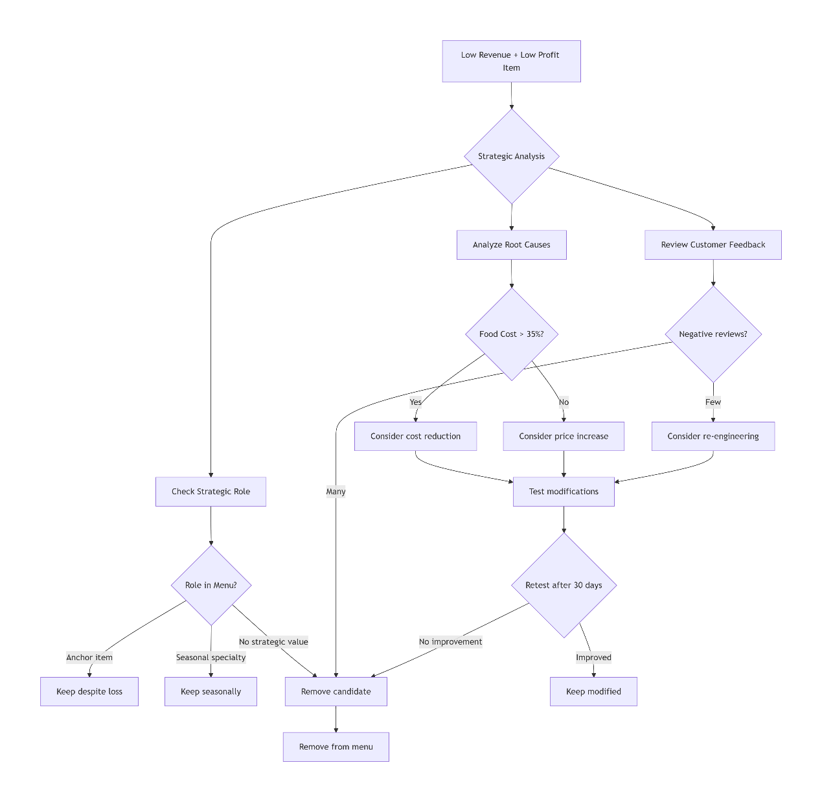

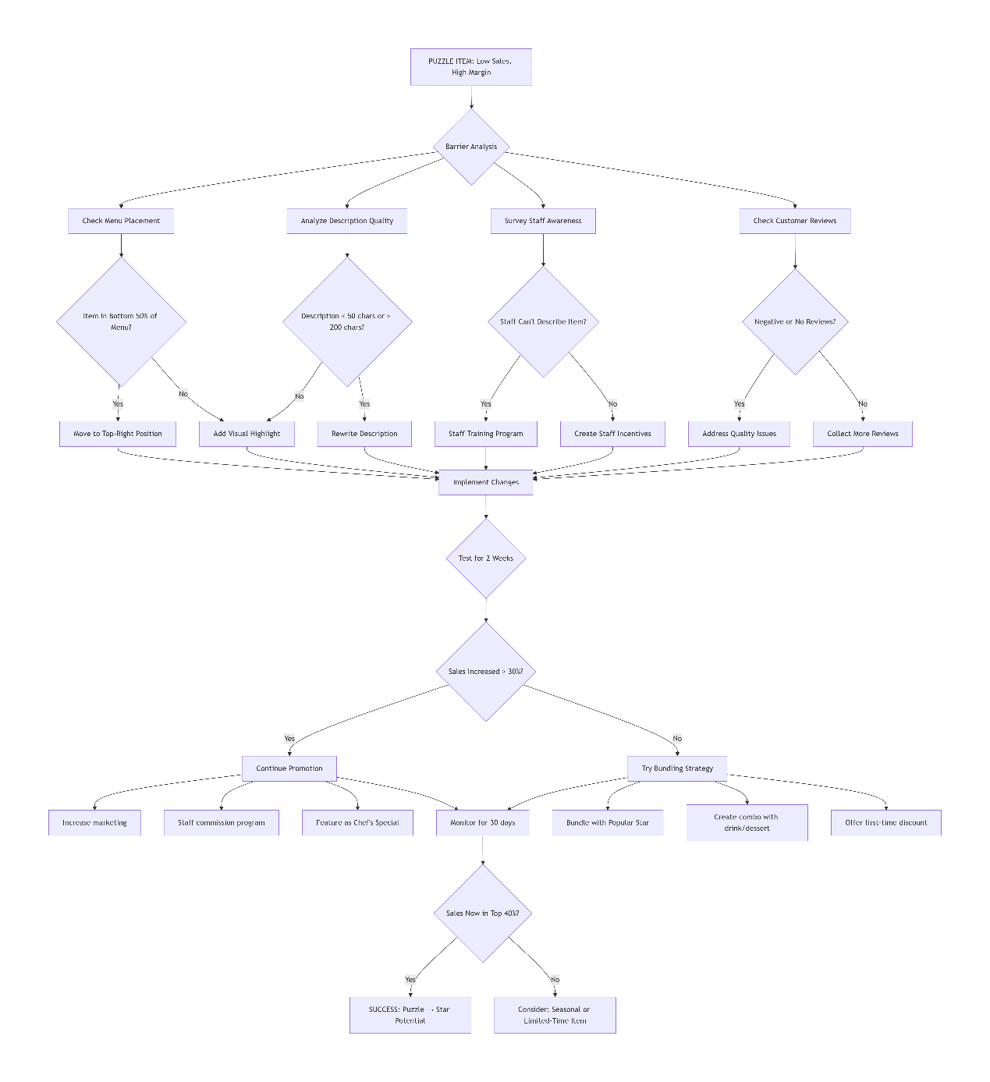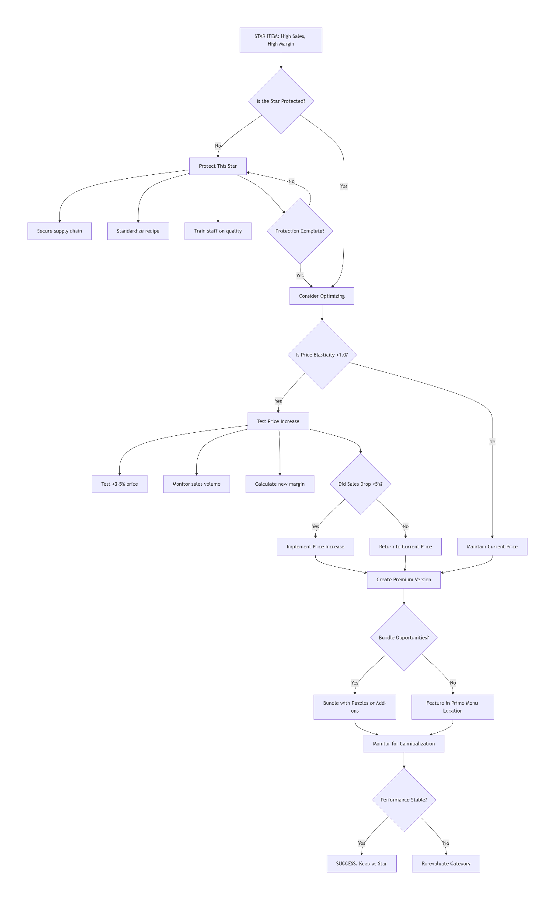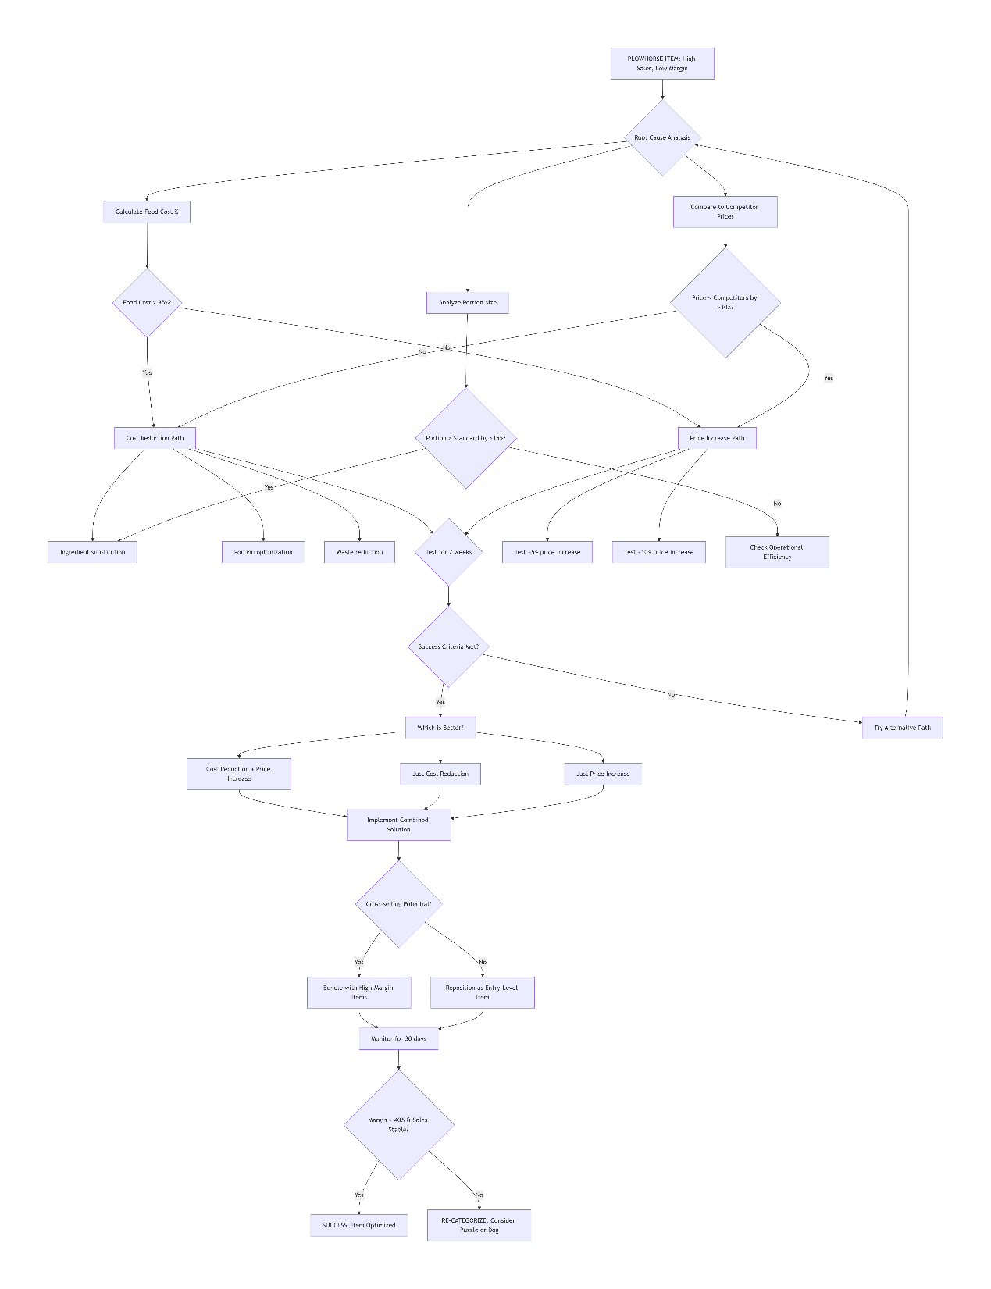
How should we adjust pricing to maximize profitability?
We can simulate it after grouping the items into 4 categories. For blowhorse, what if we increased the price a little bit, for example, 1 kkd. If the problem was with the cost, how can we control it? We want to move it towards the stars.
What wording or descriptions increase item sales?
Top-selling items: Average 42 characters (short descriptions)
Slow-selling items: Average 156 characters (long descriptions)
Conclusion: Decision fatigue is real. Customers don't read novels on menus.
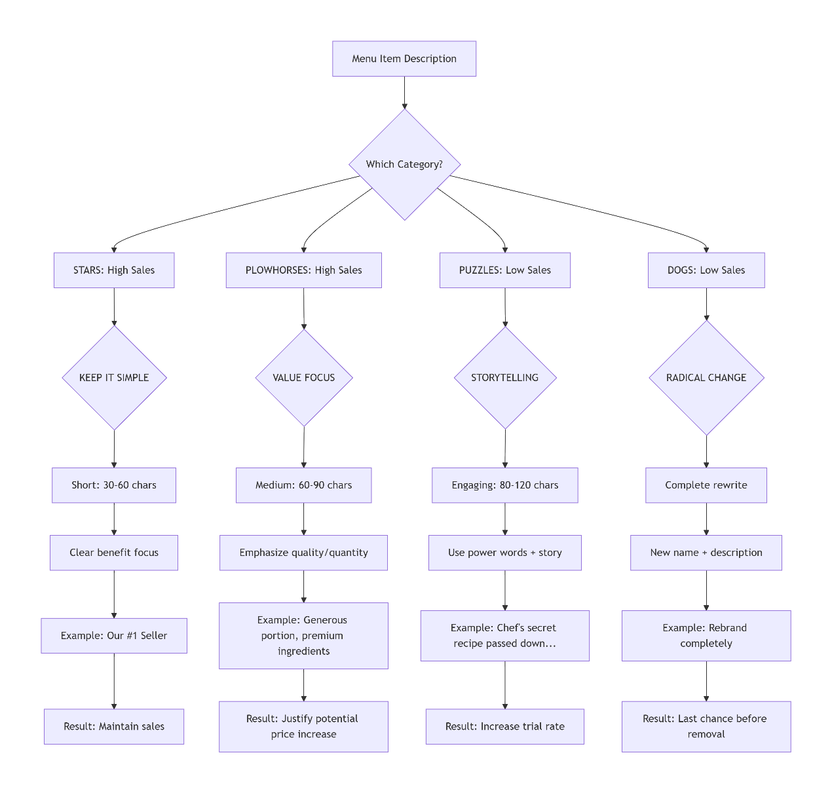
Stars:
DO:

Add "Customer Favorite" or "#1 Seller" badge.
We will know the most suitable descriptions through the historical data; we have to find the pattern behind the length of the description. It may be good a solution for puzzles.

Which items should be promoted, re-engineered, or eliminated? We solved it through diagnosing the problem

What hidden patterns exist in customer purchasing behavior?VIP WHALES 🐋 (Top 5% of Customers),REGULAR HIGH-VALUE 🏆 (Next 15%),WEEKEND WARRIORS 🎉 (15-20%), BUSINESS DINERS 💼 (10-15%),

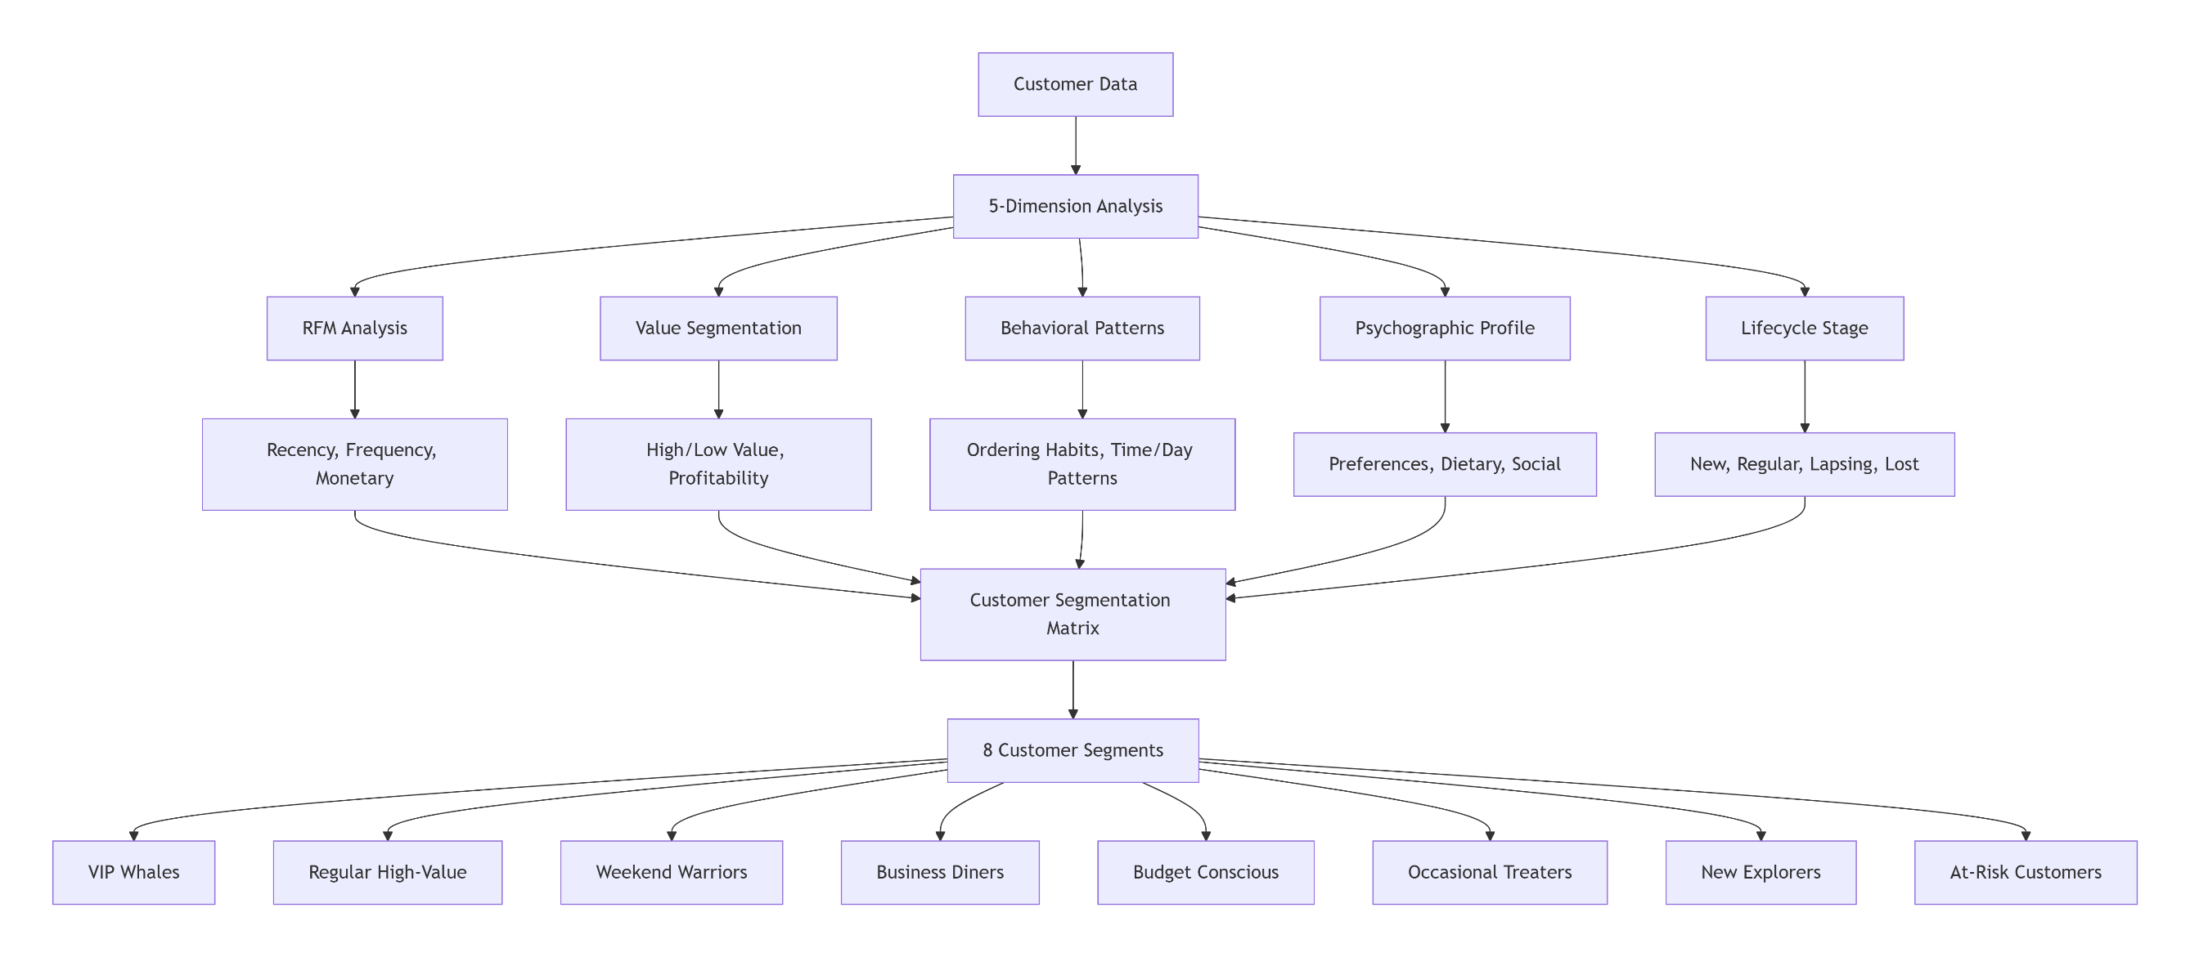
VIP Whales (5%) → Focus: Retention
Regular High-Value (15%) → Focus: Frequency
Weekend Warriors (20%) → Focus: Weekday conversion
Business Diners (15%) → Focus: Corporate accounts
Budget Conscious (25%) → Focus: Upselling
Occasional Treaters (15%) → Focus: More occasions
New Explorers (5%) → Focus: Conversion to regulars
At-Risk (5%) → Focus: Win-back

Calculate Support(A → B) = (Number of transactions containing both A and B) ÷ (Total number of transactions)

Support indicates the popularity of the product pair in the entire dataset, and Confidence equation:

Confidence(A → B) = (Number of transactions containing both A and B) ÷ (Number of transactions containing A)

Confidence focuses only on customers who purchased product A.
High support: above 15% → strong product pair.

If support is high, it means many customers buy the products together. Businesses should focus on these combinations because they impact a large number of transactions.
High confidence: above 70% → strong relationship

High confidence means customers who buy product A are very likely to buy product B.

Actions when confidence is high:

Recommend product B after A (online suggestions
Or
Offer cross-selling promotions
.

